# D09 – Functional testing

# Responsibility statements

*Identification data*

<https://trello.com/b/nlF2nmG6/d09-functional-testing> _15__________________________ __B__

URL of your project management system Group Level

URL of your project repository

Sevilla, 23/03/2018_________________________________________________

Place, date

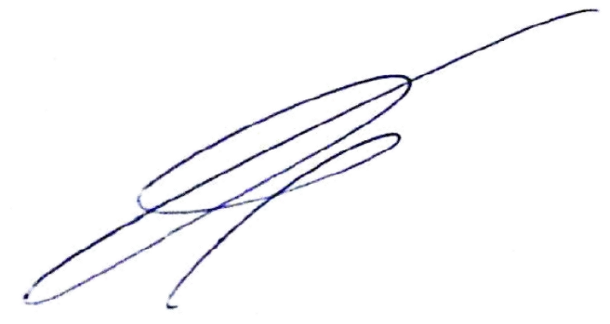

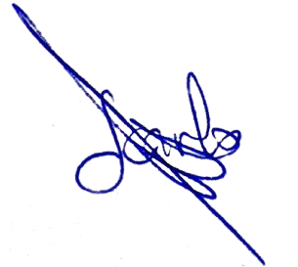 Sánchez Rodriguez, Mario _____________ Cansino Suárez, Juan Carlos ____________

|  |  |
| --- | --- |
| Student #1: Surname, name, and signature | Student #2: Surname, name, and signature |

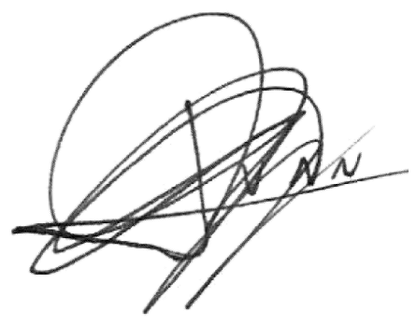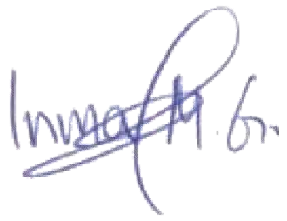 Martín Galván, María Inmaculada ____________ Rodríguez Dueñas, Juan_____________

|  |  |
| --- | --- |
| Student #3: Surname, name, and signature | Student #4: Surname, name, and signature |

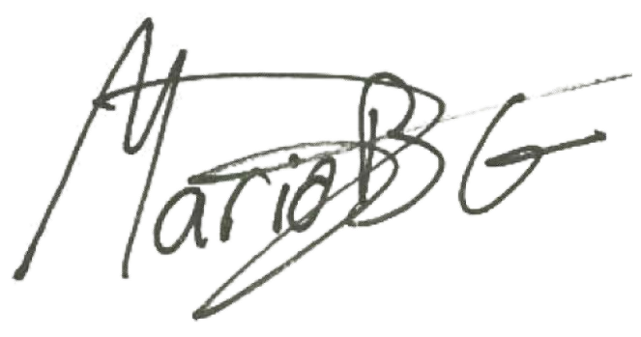 Bizcocho González, Mario__________________ __________________________________ Student #5: Surname, name, and signature Student #6: Surname, name, and signature

*Responsibility statements*

[] I am an author of this deliverable. I have not cheated in any way.

[] I have collaborated with my partners on producing this deliverable; in other words, neither have I ridden their coattails nor gobbled them up.

[] I have learnt from working on this deliverable, so that I can pass my control checks.

[] I have organised this deliverable according to the guidelines that are available in document “On your deliverables.pdf”, which is available at the USE’s e-learning platform.

[] I understand that my deliverable will be considered failed if I fail to meet any of its requirements, if I fail to submit it by the deadline, or if I do not deliver a filled copy of this form.

[] I understand that failing this deliverable might amount to failing the subject.

[] I understand that I must have a contingency plan and that submitting my deliverable very close to the deadline is likely to result in disaster.